• **Write a program to check whether the user entered string is palindrome or not.**

**Program:**

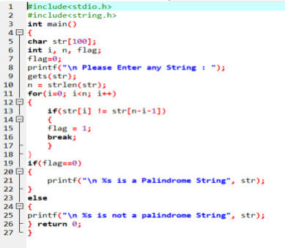**Output:**

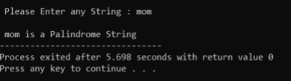

• **Write a c program to check whether the user entered year is leap year or not.**

**Program:**

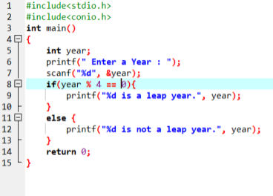**Output:**

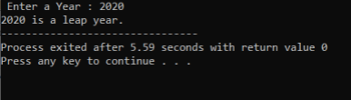

• **Write a c program to check whether the user entered number is Armstrong or not.**

**Program:**

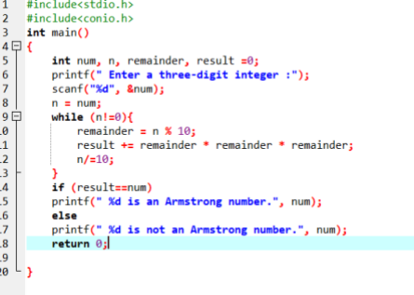**Output:**

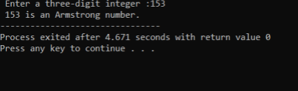

• **Write a program to check whether the input number is prime or not.**

**Program:**

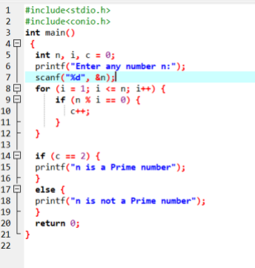

**Output:**

